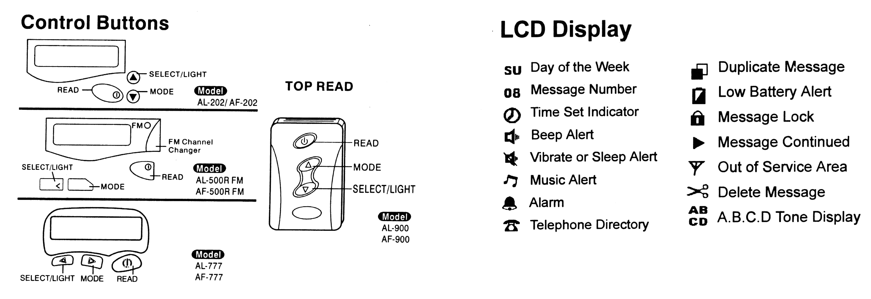

POWER ON:

Press and release the “READ” button. The pager alerts as it powers up. Now the pager is on standby.

POWER OFF:

Press “MODE” button until OFF appears in the LCD window. The Press “SELECT” button. When the pager is off, current time and alarm functions work normally. All messages that were received prior to turning the unit off will remain in memory.

SET ALERT:

The pager has 3 standard alert modes; you can select one mode among audio (beep or music), vibration or sleep (no alert) with the “MODE” button while the pager is on.

Audible Alerting: When the pager is initially turned on, it is automatically set to a AUDIO alert. To change this alert to another beep or melody, press the “MODE” button until “SET ALERT?” is displayed on the LCD. Press the “SELECT” button once and the pager displays “AUDIO?”. Choices include MUSIC melodies 1-10 and BEEP alerts 1-4. Press the “SELECT” button again and the pager will display the current alert choice. By pressing “MODE” button, you can scan the 10 music melodies and 4 beep alerts. Choose the desired alert by pressing “READ” button.

Vibration and Sleep alerts: VIBRATION will silently alert you while SLEEP alert emits no alert at all. To set, press the “MODE” button until “SET ALERT?” is displayed. Press “SELECT” button once, then the “MODE” button until the pager displays “SILENT?” on the display for vibration, or “SLEEP?” for no alert. When you make your selection, press the “READ” button.

MESSAGE MODE:

When a message is received, the pager displays “1 Page” on the LCD and depending on the alert mode selected:

BEEP – emits a 16 second beep alert
Music – melodie plays twice
Vibration – 8 second vibration
Sleep – no alert.

To stop any alert, press any button.

Reminder Alerts: If no button is pressed after a message is received, a reminder alert will emit every 2 minutes (except in sleep mode).

To read a message: Press the read button to read a message. If the message is continued the mark “>” displays. To continue, press the “READ” button again. Date and time are stamped on each message received.

LCD BACKLIGHT:

When needed, pressing the “SELECT” button can activate a backlight. The light will automatically shut off in 20 seconds after no activity, or press the “SELECT” button again to turn the light off.

DUPLICATE MESSAGE INDICATOR:

Messages received more than once will be mated with a message indicator symbol.

LOCKING:

Locking a message can help prevent the accidental deletion of a message. Up to 8 messages can be locked at a time. Using the “READ” button, select message to be locked. Press the “MODE” button until the lock symbol appears at the top of the display, then press the “SELECT” button. Message has been locked and cannot be deleted unless unlocked.

UNLOCKING:

To unlock a message, using the “READ” button, select the message to be unlocked. Press the “MODE” button once to remove the lock symbol. Message can now be deleted.

TO ERASE ONE MESSAGE:

Using the “READ” button select the message to be deleted. Press the “MODE” button until the scissors symbol appears at the top of the display, then press the “SELECT” button to delete the message.

TO ERASE ALL MESSAGES:

In standby mode, while not viewing any messages, press the “MODE” button twice until “CLEAR ALL?” appears in the display. Press the “SELECT” button once. All unlocked messages are now deleted.
NOTE:
The locked messages are not deleted in “CLEAR ALL” mode. To delete all messages in the “CLEAR ALL” mode, first unlock any locked messages.

TO SET TIME AND DATE:

Press the “READ” button until “SET TIME?” appears in the display. Press the “SELECT” button once.
- Use the “MODE” button to pick the current day of the week. The charter letters appear in the top left of the display. (EG. SU= Sunday MO= Monday) Then press the “SELECT” button once.
- Press the “MODE” button to choose the month. (EG. 5=MAY 6=June) Then press the “SELECT” button once.
- Press the “MODE” button to choose the day of the month.

ALARM:

This pager comes with an alarm function that will make the pager alert at a specified time every day whether the pager is on or off. There are 3 separate alarms that can be set for different times of the day.

To turn the alarm ON/OFF:
- When the pager is initially turned on, press the “MODE” button until “SET ALARM” appears in the display.
- Press the “SELECT” button once to enter the alarm mode. To set alarm #1, press the “SELECT” button again and the word “OFF” will blink. TO turn ON, press the “MODE” button once.
- Press the “SELECT” button once again, then using the “MODE” button to change the hour to the desired number.
- Press the “SELECT” button once to go to the minutes and using the “MODE” button, change the minutes to the desired number. Repeat for AM or PM
When complete, press the “READ” button. For alarms 2 and 3, after accessing alarm function, press the “MODE” once more for alarm 2 and again for alarm 3. Set these alarms the same way as alarm 1. To turn any alarm off, while in the alarm mode, change the “ON” to “OFF”

DIRECTORY:

The directory (with the ability to store up to 10 numbers) can be used as an additional memory or as a phone book to store your important numbers. While reading the message, you can import a copy of the message into the directory. To do so, press the “SELECT” button until a phone symbol appears in the top of the display. Press the “MODE” button to imprint a copy of the message into your directory (Please note, the directory can only store 12 digits per memory, and is unable to store alpha canned messages.) To access your directory, press the “SELECT” button until “DIRECTORY” appears in the display, and press the “MODE” button. Use the “READ” button to read through all you directory messages. Messages stored in the directory can be also locked/unlocked and individually erased.

FM RADIO OPERATION FEATURES: (500R MODEL ONLY)

To utilize your FM radio, insert the earphones in to the slot provided on the end of the pager. Once the red light is illuminated, you can start tuning the radio to the desired station with the furthest right hand button. The radio tuner has auto scan capabilities; therefore it will automatically search for any available station. Unplugging your earphones will turn the radio off automatically.

The FM radio function and the paging function are operated on 2 separate bandwidths; therefore utilizing one will not cause interference to the other.
Pleas note, using the FM radio will dramatically decrease the battery life; therefore for best paging reception please always change the battery whenever the low battery symbol appears.

CANNED MESSAGES:

OO | C-U- LATER | 14 | HURRY UP | 28 | HAVE LUNCH?
O1 | TURN ON CELL | 15 | WAITING 4-U | 29 | HAVE DINNER?
O2 | HAPPY B-DAY | 16 | EMERGENCY | 30 | WANNA GO EAT
O3 | COME HOME | 17 | MEET AT CAFÉ | 31 | WANNA HANG?
O4 | CALL HOME | 18 | MOVIES | 32 | YES
O5 | DO NOT 4-GET | 19 | ARCADE | 33 | NO
O6 | GOOD NIGHT | 20 | MALL | 34 | MAY BE
O7 | HELLO | 21 | PLAY B-BALL | 35 | CLUBBING
O8 | HOW ARE YOU? | 22 | PLAY Q-BALL | 36 | MEETING
O9 | I LOVE YOU | 23 | PLAY CARDS | 37 | SO COOL
10 | I NEED YOU | 24 | GO BOWLING | 38 | HI! BABY
11 | I MISS YOU | 25 | GO CRUSING | 39 | I DINNO
12 | NEED HELP | 26 | GO SHOPPING
13 | NEED INFO | 27 | GO SWIMMING

When your friend pages you, they can add “#00” – “#39“ (any choice). They are able to link up to 4 canned messages.

Example:

- Dial pager number and wait for connected tone
- Press “*” once. Then press “#09” and the number you wish the person to call you back at.
- Press “*” twice to end the call

The pager will display the following:

- The pager will first display “I love you”
- The pager will then display the phone number you entered.

Battery Information:

- This pager uses only AAA alkaline batteries. Do not use “Heavy Duty” batteries or rechargeable batteries. These batteries may cause damage to the pager and will void the pager warranty.
- When battery is low, “LO-BATTERY” and the low battery symbol will be shown on the display. To remove the old battery, slide the battery door to the right to open. Remove the old battery. Align the new battery so that the positive (+) and negative (-) marking are in the proper position, and insert the new battery. Replace the battery cover and press the “ON” button to make sure the pager powers on.

